Real-time Estimation of Heart Rate under lighting using Web Camera

Deepak M D  
Assistant Professor  
Department of CSE  
Presidency UniversityBangalore, India  
deepak.md@presidencyuniversity.in

Guna Shree U  
Department of CSE  
Presidency UniversityBangalore, India  
201910100453@presidencyuniversity.in Galam Anusha Priya  
Department of CSE  
Presidency UniversityBangalore, India  
201910101473@presidencyuniversity.in

Harshini A P   
Department of CSE  
Presidency UniversityBangalore, India  
201910100083@presidencyuniversity.in Gonuguntla Goutham Sai   
Department of CSE  
Presidency UniversityBangalore, India  
201910101442@presidencyuniversity.in

Hemanth Konduru   
Department of CSE  
Presidency UniversityBangalore, India  
201910102182@presidencyuniversity.in

*Abstract*— The early detection of variation in heart rate is essential for effective treatment because cardiovascular disease is one of the leading cause for death worldwide. In the field of medical diagnostics, heartbeat detection is a crucial task, but conventional methods call for specialized tools and qualified personnel. The use of signal processing and computer vision techniques has gained popularity in recent years. This study describes a technique for real-time heart rate monitoring using a webcam and JavaScript. The suggested method takes the facial region out of the webcam's video frames and uses signal processing to estimate the heart rate. In particular, the technique detects the subtle color changes brought on by the blood flow in the skin and uses the chrominance information of the facial region to estimate the heart rate. The method also employs motion compensation algorithms to decrease the impact of head motions and facial expressions on heart rate measurement. The suggested approach can offer a low-cost and non-invasive way to detect a person's heart rate and has potential applications in healthcare, fitness monitoring, and wellness tracking.

Keywords—Cardiovascular disease, Computer vision (CV), Signal processing, Heart rate (HR), Motion compensation.

# Introduction

Since many years, physiological signal analysis has been used extensively in the field of medical research. Research has demonstrated that heart rate is a source of data that reveals a person's psychophysiological status. Aside from HR change measures, several medical diagnoses also make use of breathing rate and ECG signals. The progression of novel pulse-measuring methods and machine intelligence algorithms enabled the identification of tension, sleepiness, and different emotions. The advancement of non-invasive physiological sensing technologies will result in a slew of new applications since they will be rapid, simple, and attainable in real time. This research presented a real time face video heart rate tracking system utilizing a web camera by estimating the variation in skin color produced by heartbeat.

The idea of monitoring cardiovascular system parameters without contact with the human body has developed. The circulatory system allows blood to flow throughout the body due to the heart's continuous blood pumping. The resulting blood supply creates colour change in the skin on the face with each beating, and HR may be calculated using this colour variation.

Previously, a few techniques for pulse detecting using a camera were developed, however such procedures have restrictions on the elements impacting colour values, such as variances in ambient illumination during video recording and variations in blood parameters produced by heartbeat. Most non-touch methods use RGB colour space to produce face footage that is best suited for lab settings or constant ambient lighting. Because the ambient light is not constant, these approaches are not appropriate for real-time software and cannot achieve heart rate.

The proposed technique employs LAB colour space for non-intrusive heart rate detection, hence eliminating ambient light changes while extracting face pictures. The suggested process starts by locating the Region of Interest (ROI) on the face and identifying the skin likely region, followed by using LAB colour space. The colour fluctuations are then examined for every pixel in time and amplified to obtain a closer picture of the signal from the chosen ROI. Finally, the captured area is used to extract the signals from which the HR is extracted using peak detection algorithms.

# Associated Work

For the past decade, academics have been engaged on computer vision (CV) technologies. The first proposed use of using facial assistance for observations to measure physiological parameters in human beings. Verkruysse provided an example of how to use PPG to calculate HR from a person's face in natural light. The key concept behind these techniques is to get the pulse based on transient changes in facial colour using blind source separation (BSS). Additionally, researchers applied algorithms for various techniques to optical processing and noise reduction to specifically analyse HR estimations.

Earlier systems detected pulses from collected video by calculating small head motions resulting from the Newtonian reaction to flow of blood by every heartbeat. Here, compliance with artery and head mechanics, as well as erratic and inadequate illumination circumstances, may have an impact on how well the features are monitored. Medical applications for ambient light-based virtual plethysmography imaging include vascular skin lesion characterization and vital signs are remotely monitored for sports or triage. The prerequisite in this instance is to quantify heart and breathing rates will result in less accurate findings.

With adaptive filtering techniques like Normalised Least Mean Square, remote HR observations from face films are conducted under controlled conditions to quantify HR. Changes in ambient illumination and movements that enhance subject interference reduce their effectiveness. Webcam-based face footage in RGB colour space is used for HR monitoring. The HR was calculated using a straightforward webcam in an indoor setting with continuous ambient light from the colour change in the skin caused by heartbeat. This approach can't determine where HR is fluctuating due to the surrounding light, making it unsuitable for real-time applications.

Our goal is to create a non-contact heart rate estimating device that uses a camera to track the variation in skin tone caused by each heartbeat. The gathered footage is converted from RGB to LAB colour space using signal processing techniques like the Fast Fourier Transform (FFT), and a face identification algorithm is used to remove the impact of ambient light. The HR is then determined from the frequency that was obtained using a peak detection method.

# Proposed Methodology

This technique's fundamental premise is that blood flowing down the face alters the skin's hue in a way that is apparent to the camera but invisible to the human eye.

There isn't much information in the sections for the eyes, lips, and nose. So, to obtain regions with skin probability, we apply a skin mask. The signals in the skin mask that are accessible from that place are the next step after obtaining the skin mask. Then, using this signal's peak detection method, the heart rate is calculated.

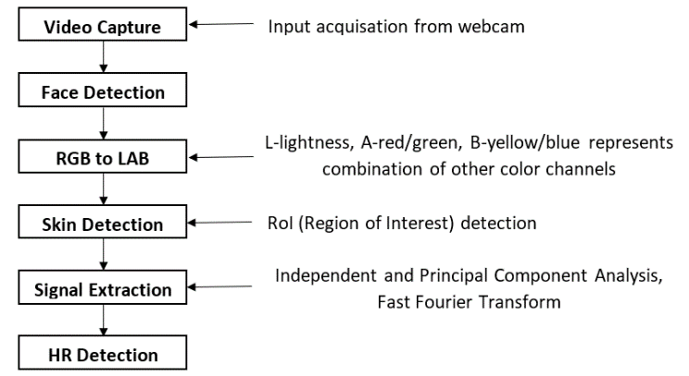

Fig. 1. Workflow of the method

## Record Video with Webcam: A subject (human) sits in front of a webcam and records footage.

## Face Identification: The Affine transform algorithm is employed. High identification efficiency, few false positives, and practicality are some of this algorithm's characteristics.

1. Haar Feature Selection: There are a few traits that are common to all human faces. The area around the nasal bridge is lighter than the eyes, and the upper cheek are paler than the eye rims. These comparisons can be ordered using the haar function.

value = Σ (black region pixel) − Σ (white region pixel).

1. Integral Imaging: Integral pictures analyze rectangular characteristics in a consistent amount of time. Compared to previous systems with more attributes, this increases computation time while improving computation speed. The quantity does not affect how quickly features are processed.



Fig. 2. Integral Image creation Features

1. OpenCV Algorithm: This method is used to train classifiers as well as facial recognition algorithms to choose the best features.
2. Cascade in OpenCV: There is a potential classifier at every level of the cascade. The purpose of each stage is to establish if a certain plane is unmistakably a face. The recognized pane will be automatically discarded if it is not a face.

## RGB to LAB Colour Space Conversion: Here, RGB photos of the same items taken with various camera types and ambient illumination appear differently. The LAB colour space is independent of unit. Here, the ‘L’ denotes the image's brightness, the ‘A’ and ‘B’ colour channels denote additional colour combinations, and the ‘A’ represents the red or green component colour. A negative ‘A’ is represented by green, and a positive ‘A’ is represented by red. Yellow or blue are represented on the ‘B’ axis. Yellow denotes positive values of ‘B’ and blue indicates negative values of ‘B’. The numbers L=0, A=0, B=0, depict absolute black and L=100 depict white. In the RGB colour space, light is a significant factor, although in outdoor settings, it is not as significant.

## Skin Identification: All unnecessary regions that do not give useful information, such as nostrils, eyebrows, and eyes, are detected and removed using a skin classifier.

## Signal Amplification: The three signals used in the LAB colour space are ‘L’, ‘A’, and ‘B’, where ‘L stands for the brightness of the image and ‘A’ and ‘B together stand for its fusion of the other two channels. L lacks color information, thus you must separate A and B channels of color to from it. Blood pulses cause minute changes in brightness and intensity that are recorded in the LAB colour space. Independent Component Analysis or Principal Component Analysis reduces dimensionality when utilised.

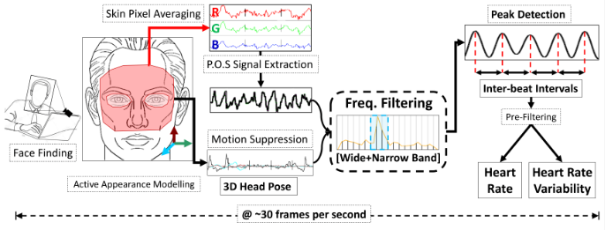

## Fig.3. Architecture of RPPG

## HR Recognition: HR can be calculated from the recovered signal using time or frequency-domain analysis. The Fast Fourier Transform (FFT) can be used to convert signals into the frequency domain. A signal that has been sampled over a predetermined amount of time is used to determine the signal's peak detection method. The person's detected HR is reported as this peak value. Peak-finding algorithm following the Fast Fourier Transform's conversion of the signal to the frequency domain. We must first count the frequency range's peaks and keep track of how long it takes for the first 30 frames of the image before we can calculate the heart rate in real-time. Thus, the formula for measuring heart rate is HR = 60*(frequency extracted) bpm.The amount of peaks within a given period of time is the extracted frequency in this case.

## So, HR = [60 x (total peak/time)]  bpm.

For example, 25 peaks for 600 frames where frame rate per second (fps) is 30 and time taken to read 600 frames will be 20. HR = [60 x (25/20)] = 75 bpm.

# Requirements

The project does heavily depend on software and limited hardware.

## Hardware Requirements

Desktop or mobile device: Any dual core process or higher with > 1 GHz.

Camera or webcam: Any camera or webcam which is >= 1 MP, and a resolution of 720p or higher.

## Software Requirements

Any web browser (Firefox 81 or later, Chrome 85 or later, Edge 85 or later, Safari 14 or later, Opera 67 or later and Brave 1.14.81 or later) to run the software.

Programming Languages: HTML, CSS and JavaScript

Library: OpenCV

Other tools: Remote photoplethysmography (RPPG)

# Implementation

## Video Recording: The camera is currently linked. The webcam captures video and reads picture metadata to extract frame capture times.

## Face Recognization: Eliminates extraneous data, such as the background, since we are only interested in a person's face. Establish the face's limiting box. The video is trimmed to the face's bounding box.

 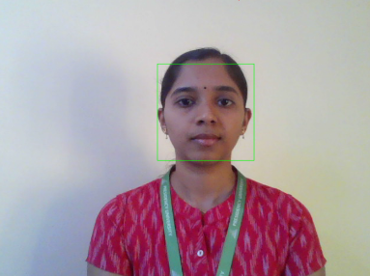

Original Image Face Detected Image

Fig.4. Face Detection

## Frame Registration: In order to observe the variation in skin tone on the subject's head, the video needs be filtered. Consequently, locate the altered face in relation to original face. Reverse the alteration once the face shift has been identified to stabilise image. It is decided which change in expression corresponds to the initial frame. The adjustments can be reversed to stabilise the video.

## Skin Interpretation: Establishing a baseline skin categorization that can recognise facial skin grounded in LAB colour. Change the face colour space to LAB. The face border region averages distribution of skin probabilities.

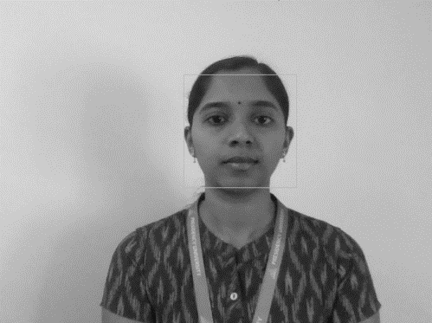

Fig.4. Grayscale Image

## Color Coding: Plot the A and B signals in order to see how the subject's head's skin tone varies, as HR is situated between the two and uses skin weight to obtain the signals for all LAB frames. Both the differences in light and the variations in the intensity of the blood pulse are seen. Then, using the proper de-mixing perspective, the A and B signals are combined to create the signal that represents the heartbeat. Calculate the likelihood of skin from each image's pixels to obtain the average LAB colours and the best heart rate signal.

## Heart Rate Measurement: A bandpass filter is applied to modulate the heart rate signal using frequencies between 0.5 Hz and 3 Hz. Isolate the HR peaks obtained. Convert the frame counts into times. Synthesise different heartbeats from calculating interval averages.

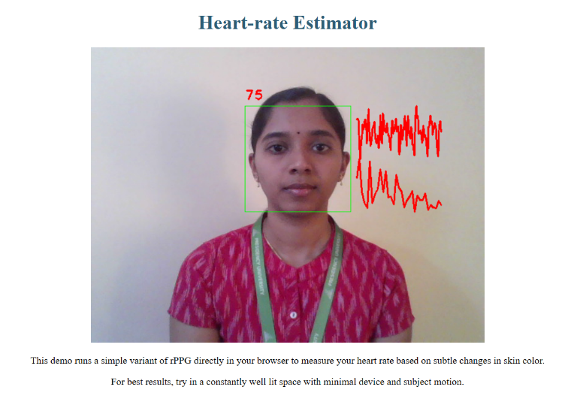

Fig.5. Output Snapshot

# Results

This device offers the most effective webcam-based real-time HR monitoring method. It will open numerous cool uses both within and external of the hospital, such as converting video surveillance cameras into heart attack early warning detectors and reducing the cost of medical treatment by eliminating more expensive monitoring equipment. This method enhances Human Computer Interactions (HCI) by providing computers with direct emotional clues.

By gathering real-time input from the webcam, this device may determine a person's heart rate (HR). A short video clip is captured by setting the frame rate to 10 frames per second and instructing the subject to stand or sit in front of the camera. The complete face is used as the Region of Interest in the video to calculate HR. When the ROI for the complete face is taken into consideration, HR is identified, although the accuracy levels were low. This happened as a result of the camera's assessment of undesired facial areas where blood flow cannot be identified with accuracy. Thereafter, with the aid of haar feature selection, the relevant areas where the blood flow may be apparent, such as the cheeks and forehead, are indicated using facial coordinates. To provide a mimicked environment and lessen light variance, this area was selected as an ROI for additional processing and transformed into LAB space. A and B are a synthesis of the other two channels, whereas L denotes the picture's lightness. After separating L from LAB, use color channels A and B to measure HR since L has no understanding of color.

Various kinds of cameras and varied ambient lighting are used to capture RGB images. Take advantage of a band-pass filter to gather the required signals from the ROI that was spread apart for the lab and a peak-detection algorithm to analyze the variations. Extract the HR from the peak intervals. Then translate the frame numbers into intervals that correspond to heartbeats. The values gleaned from the created system are displayed below.

TABLE I

Sample Heart Rate Readings

| **S. No** | Heart Rate (bpm) | Image |
| --- | --- | --- |
| 1 | 74 |  |
| 2 | 76 |  |
| 3 | 75 |  |
| 4 | 79 |  |

# Conclusion and Enhancements

The instantaneous non-contact heart rate estimation system using face video described in this work is simple to use, affordable, and suitable for real-time applications, that is functional in dim lighting. Because light contributes significantly to RGB video, heart rate monitoring with RGB is problematic in outdoor conditions. This method includes a way to determine heart rate by employing LAB-colored face images. The LAB color space is independent of hardware.

Heart rate (HR) is examined and contrasted with numerous test instances, including variable lighting and skin tones. The transformation of the RGB into LAB color scheme had a significant influence in the result of achieving high levels of accuracy by offering a viable remedy for the fluctuating skin tone. Here, a technique for calculating the HR using video footage of a person's face and gestures using a camera with ambient light illumination is provided. On the basis of the experimental findings, it is considered that the HR ranges between 60 and 110 bpm under typical circumstances. Our investigation suggests that the HR may be detected with 90% accuracy.

It can be used for routine patient observation in home care, this approach is extremely effective, comparatively successful, and simple to implement. This contactless innovation is advantageous for indoor and medical applications due to the prevalence of cameras, particularly webcams. For future applications a few elements, such as head movement or varying ambient lighting should be addressed. Future work will concentrate on creating a multiparameter, real-time measuring network based on this technology with enhanced video resolution. While this research mainly examined cardiac HR recovery, the approach suggested may be used to determine many other essential factors such as variability of heart rate, respiratory or breathing rate and blood oxygen saturation.

##### References

1. D. Qiao, R. Masroor, R. Rasool, F. Zulkernine and N. Jaffar, "Measuring Heart Rate and Heart Rate Variability with Smartphone Camera," 2021 22nd IEEE International Conference on Mobile Data Management (MDM), Toronto, ON, Canada, 2021, pp. 248- 249, doi: 10.1109/ MDM52706.2021.00049.
2. S. Yu et al, "Human Heart Rate Estimation Using Ordinary Cameras under Natural Movement," 2015 IEEE International Conference on Systems, Man, and Cybernetics, Hong Kong, China, 2015, pp. 1041-1046, doi: 10.1109/SMC.2015.188.
3. J. Zhao, G. Jia, J. Huang, X. Ji and L. Shan, "Non-Contact Method of Heart Rate Using a Webcam," 2018 IEEE International Conference on Internet of Things (iThings) and IEEE Green Computing and Communication (GreenCom) and IEEE Cyber, Physical and Social Computing and IEEE Smart Data, Halifax, NS, Canada, 2018, pp. 1902-1906, doi: 10.1109/Cybermatics_2018.2018. 00315.
4. C. Wang, Y. Jiang, L. Lin and Z. Cai, "Non-contact Measurement of Heart Rate Based on Facial Video," 2019 Photonics & Electromagnetics Research Symposium - Fall (PIERS - Fall), Xiamen, China, 2019, pp. 2269-2275, doi: 10.1109/PIERS-Fall48861.2019.9021402.
5. M. Oviyaa, R. Swathika and P. Renvitha, "Real Time Tracking of Heart Rate from Facial Video Using Webcam," 2020 Second International Conference on Inventive Research in Computing Applications (ICIRCA), Coimbatore, India, 2020, pp. 1-7, doi: 10.1109/ ICIRCA48905.2020.9183124.
6. Rouast P.V, Adam M.T.P and Chiong, "Remote heart rate measurement using low cost RGB face video", 2018 Front. Computer Sci. 12, 858–872.
7. T. Blöcher, M. Schinle, J. Schneider and W. Stork, "An online PPGI approach for camerabased heart rate monitoring using beat-to-beat detection," 2017 IEEE Sensors Applications Symposium (SAS), Glassboro, NJ, USA, 2017, pp. 1-6, doi: 10.1109/SAS.2017.7894052.
8. El khadiri, Z, Latif, R, Saddik, A (2023). Remote Heart Rate Measurement Using Plethysmographic Wave Analysis. In: Aboutabit, N., Lazaar, M., Hafidi, I. (eds) ICMICSA 2022, doi: 10.1007/978-3-031-29313-9_23.
9. T. Kitajima, E. A. Y. Murakami and S. Choi, "Heart rate estimation based on camera image," 2014 14th International Conference on Intelligent System Design and Applications, Okinawa, Japan, 2014, pp. 50-55, doi: 10.1109/ISDA.2014.7066275.
10. K. S. Alam et al, "Remote Heart Rate and Heart Rate Variability Detection and Monitoring from Face Video with Minimum Resources," 2020 IEEE 44th Annual Computers Software and Applications Conference (COMPSAC), Madrid, Spain, 2020, pp. 1385- 1390, doi: 10.1109/COMPSAC48688.2020.0